To help you get off to a smooth start in the new year, we’ve compiled a checklist of financial and configuration tasks that are commonly completed at year end and how they look in Acumatica.

Generate and Activate New Financial Periods

- Navigate to Master Financial Calendar screen (GL201000).

- Verify if the new year is already available in Financial Year dropdown. If not, click Generate Calendar. In popup box, select which year you need to generate and click OK. Periods for the year will be generated and will be inactive on default.

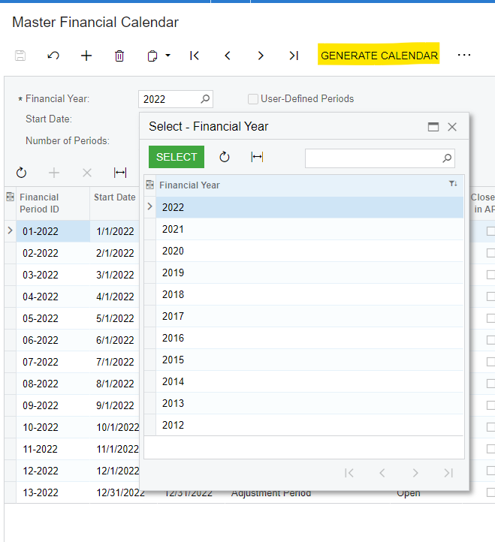

- To activate periods, click three dots > Open Periods.

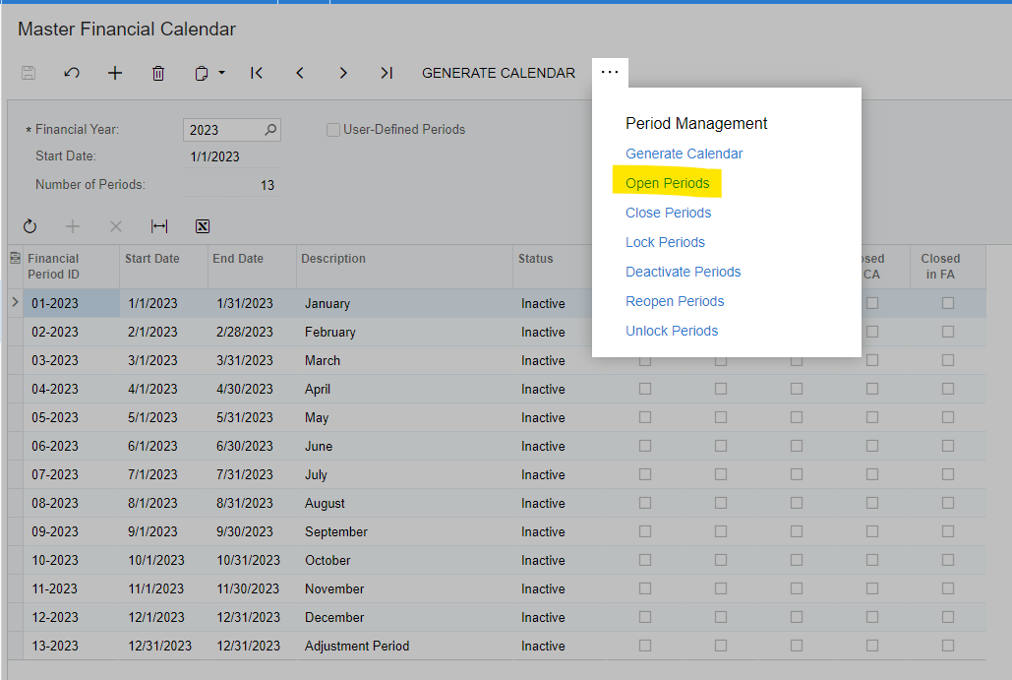

- On the Manage Financial Periods screen (GL503000), select specific period(s) or all periods for year to open and click Process.

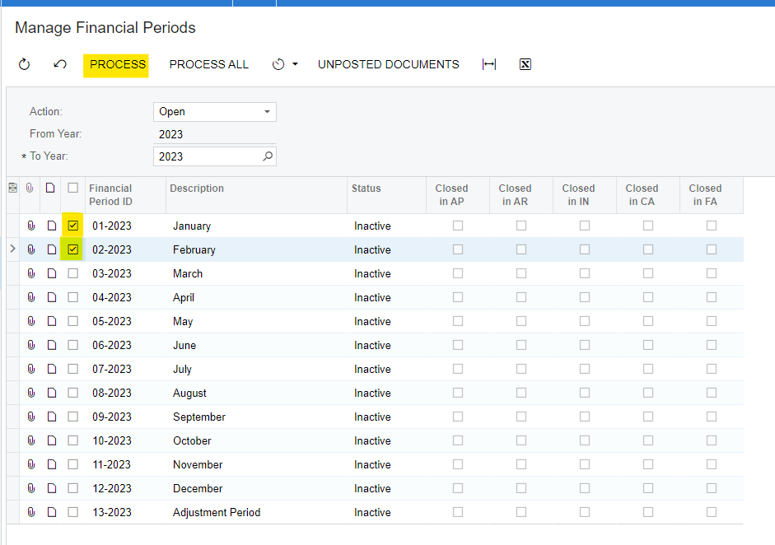

Account Reconciliations with Subledgers

Make sure that all of your General Ledger accounts are reconciled to the subledgers (i.e. A/R, A/P, Inventory, Clearing Accounts and Bank Reconciliations).

U.S. Form 1099 Reconciliations, Reports and Close 1099 Year

Over the last two years, format updates made to United States 1099-MISC & 1099-NEC forms have resulted in potential alignment issues to older Acumatica versions and builds. Read below to see if there are any anticipated impacts to your build for how you plan to process your 1099's.

Do you use Acumatica to print 1099 forms?

If you are on a 2023 version of Acumatica, no problems are anticipated!
If you are on a 2022 version of Acumatica, the following builds resolve possible alignment issues.

2022 R2 Update 3 (22.203.0043) or later
2022 R1 Update 14 (22.114.0029) or later

Do you use Acumatica E-File 1099 forms?

If you use Acumatica to e-file 1099 forms the following builds are updated.

2023 R2 Update 3 (23.203.0040) or later {released Nov 17, 2023}
2023 R1 Update 13 (23.113.0042) or later {released Nov 24, 2023}
2022 R2 Update 20 (22.220.0026) or later {released Nov 10, 2023}
2022 R1 Update 26 (22.126.0004) or later

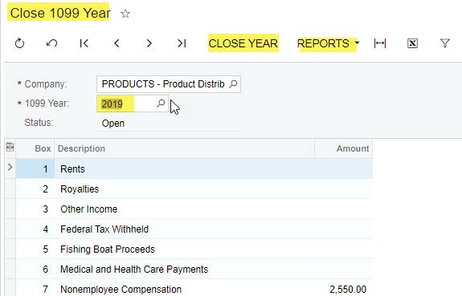
If you think you might need to update your build to correct alignment issues log a ticket with acumatica.help@i-techsupport.com.

Once ready to process, verify your 1099 vendor calculations, create the required reports, and close the 1099 year once completed.
System Configuration Changes

If you are considering making any system configuration changes (i.e. – GL Account Classes, Customer Classes, Vendor Classes, Item Classes, etc.), it may be a good time to do this at the beginning of the New Year.

Sales Tax Changes

Verify if there are any sales tax changes that will be going into effect on January 1st in the areas where you are doing business.

Customer and Vendor Price Changes

Vendor or Customer price changes often occur on the 1st day of the New Year. You may want to consider updating these prices in your system to ensure accuracy of your purchase orders and sales orders.

Financial Reporting Changes

Some Financial reports may have been built using specific reporting periods. If so, they may need to be modified for the new fiscal year.

Space here for any other tasks specific to your business you’d like to add.

_________________________________________

_________________________________________

_________________________________________

Questions about Year-End Tasks you need to complete in Acumatica?

If you work with i-Tech as your Acumatica partner, log a support ticket if you have any questions about preparing for the new year.

